“VITAL-SENSE”, AN IOT BASED PATIENT HEALTH MONITORING SYSTEM

A PROJECT REPORT

SUBMITTED BY
SL NO. | NAME | UNIVERSITY ROLL NO. | STREAM
1. | ANIRBAN SAHA | 430522010015 | EIE 2nd Year
2. | SOMSHUBHRA BOSE | 430522010013 | EIE 2nd Year

Under the guidance of
Dr. Susmita Das
Assistant Professor, Department of EIE

In
Electronics and Instrumentation Engineering
NARULA INSTITUTE OF TECHNOLOGY
81, Nilgunj Road, Agarpara, Kolkata, 700109
JANUARY 2025

CERTIFICATE OF APPROVAL

This is to certify that the students mentioned below have submitted this thesis report on “solar charged seed spraying bot using mesh networking protocol”

The report is hereby ready for evaluation.

SL.NO. | STUDENT NAME | UNIVERSITY ROLL NO. | STREAM
01 | Anirban Saha | 430522010015 | EIE – 2nd Year
02 | Somshubhra Bose | 430522010013 | EIE – 2nd Year

Dr. Susmita Das Mrs. Sanghamitra Layek
----------------------------------- -------------------------------------
(Supervisor) (TEACHER-IN CHARGE)

DATE:
----------------------
(EXTERNAL EXAMINER)

ACKNOWLEDGMENT

We would like to express our gratitude to Dr. Susmita Das, Assistant Professor, Electronics and Instrumentation Engineering, Narula Institute of Technology, for her valuable guidance, which helped us a lot in due course of the project work.
We would like to thank, Mrs. Sanghamitra Layek, Teacher-in-Charge, Electronics and Instrumentation Engineering, Narula Institute of Technology, who had given all the support for performing experiments in this regard and extended all the facilities of the department for the project work.

GROUP MEMBER NAME UNIVERSITY ROLL NO. SIGNATURE

Anirban Saha 430522010015

Somshubhra Bose 430522010013

CONTENTS

CHAPTER NO. | TOPIC | PAGE NO.
1 | 1.1 Introduction
1 | 1.2 Literature Review
1 | 1.3 Motivation Behind the Project
2 | 2.1 Project Overview
2 | 2.2 Project Objectives
2 | 2.3 Components Used for The Prototype
2 | 2.4 Details of the Components
3 | 3.1 Project Description
3 | 3.2 Result Analysis
4 | 4.1 Applications and Future Scope
4 | 4.2 Conclusion
5 | References
6 | Program Details
7 | Datasheet Of the Components
8 | Plagiarism Check

CHAPTER: 01

1.1 INTRODUCTION :
In the past few years, the rapid development of healthcare is largely attributed partly thanks to the progressive use technology to improve medical diagnosis and treatment.With the aging population, effective and continuous monitoring of patients' vital signs is a major problem facing modern healthcare, particularly for those recuperating from surgical operations.Is always difficult to achieve. this because Conventional health monitoring methods frequently require repeatedlugged visits to the hospital and response times delay impatiently for urgent medical situations. In order to meet these needs, we have implemented an IoT-based VITAL-SENSE, which is a patient health monitoring system developed for real-time and remote measurement of critical physiological parameters.
For instance, VITAL-SENSE monitors vital indicators like blood pressure, heart rate, body temperature, oxygen saturation (SpO₂), etc. by integrating intelligent biomedical sensors with an Internet of Things so cable of wireless data transmission through Wi-Fi or Bluetooth, these sensors send data to a system stored in a cloud. Data is processed and displayed on a mobile or online application, and medical experts can use this to monitor their patients. Medical care is vital, and when there are any abnormal conditions, the system has an alarm that goes to the medical providers or family so they can get the patient the aid needed making it safer for the service.
VITAL-SENSE connects smart biomedical sensors with IoT so as to keep track of the heart rate, body temperature, blood pressure and oxygen saturation levels (SpO₂). By means of wireless technologies such as bluetooth and wi-fi, these sensors gather information from the patients and send it to the cloud storage. Then it is processed and made accessible in a web-based or mobile application for the health professionals and caregivers to monitor the patients from a distant location. Moreover, the system has an alert system that automatically informs the doctor or any family member in case any of the health parameters vary severely, allowing for prompt medical assistance.
Integrating IoT technologies in health institutions has drastically changed the scope of patient care by providing ease of movement for medical professionals who do not need to monitor everyone closely, saving time on checkups, and improving preliminary assessments. VITAL-SENSE plans on delivering such services at lower price points and increasing adoption in hospital, elder care facilities, and even homes. This trend is only set to increase with the virtual care and telehealth sector focusing on improving patient experience and reducing the costs associated with patients out of care.The key goals for the VITAL-SENSE project are concerned with capturing health data in real-time, storing the data securely on the cloud, providing remote access, and creating alerts automatically. Utilizing Internet of Things (IoT) technology along with cloud computing, this specific project is aimed at building a smart ecosystem for healthcare that encourages active participation, rapid responses to emergencies, and constant monitoring of the patient in absence of manual resources.

1.2 LITERATURE REVIEW :
1. “Gubbi, J., Buyya, R., Marusic, S., & Palaniswami, M. (2013). Internet of Things (IoT): A vision, architectural elements, and future directions. Future Generation Computer Systems, 29(7), 1645-1660. https://doi.org/10.1016/j.future.2013.01.010
IoT has revolutionized healthcare in recent years by making remote patient management and real-time health monitoring possible. The importance of IoT in healthcare was emphasized by a research by Gubbi et al. (2013), which focused on how connected devices can effectively gather and analyze patient data. The study demonstrated how IoT-based healthcare systems increase productivity and lessen hospital load by examining a variety of wireless sensor networks and cloud integration strategies. According to the results, IoT-enabled real-time health monitoring can improve early illness identification and guarantee prompt action.
2. Pantelopoulos, A., & Bourbakis, N. G. (2010). A survey on wearable sensor-based systems for health monitoring and prognosis. IEEE Transactions on Systems, Man, and Cybernetics, Part C (Applications and Reviews), 40(1), 1-12. https://doi.org/10.1109/TSMCC.2009.2032660
In a 2010 study, Pantelopoulos and Bourbakis examined the developments in wearable biomedical sensors for monitoring patient health. The study examined several sensor systems that track oxygen levels, body temperature, heart rate, and electrocardiograms. It was determined that wearable technology combined with Internet of Things platforms might offer ongoing patient monitoring, lowering the need for hospital stays. The study did, however, also highlight the need for better sensor calibration methods by identifying issues including data security and the precision of inexpensive sensors.
3. Rahmani, A. M., Liljeberg, P., Gia, T. N., Islam, S. M. R., Flores, H., & Tenhunen, H. (2018). Smart e-Health gateway: Bringing intelligence to Internet-of-Things based ubiquitous healthcare systems. Journal of Sensors, 2018, 1-20. https://doi.org/10.1155/2018/9851394
Rahmani et al. (2018) looked into cloud-based systems for patient monitoring from a distance. The study presented a scalable and safe system for sending patient health data to cloud storage for real-time analysis using Internet of Things devices. The authors gave an example of how cloud computing makes it easier for medical practitioners to monitor patients from a distance. The research also addressed issues including data transfer latency and privacy problems, suggesting edge computing and encryption methods as possible remedies.
4. Rojas, E., Valenzuela, O., Rojas, I., Herrera, L. J., Pomares, H., & Rojas, F. (2020). AI and machine learning for IoT-based health monitoring systems. Neural Computing and Applications, 32(8), 11179-11198. https://doi.org/10.1007/s00521-019-04512-3
Rojas et al. (2020) looked at the function of machine learning and artificial intelligence (AI) in Internet of Things-based health monitoring. According to the study, AI-driven analytics might be used to identify anomalies in patient vitals and forecast possible health hazards. AI-enabled IoT-based monitoring systems improve diagnostic precision and offer predictive insights for healthcare prevention. The study also proposed that AI-driven IoT systems can enhance emergency decision-making and lower false alerts.

1.3 MOTIVATION BEHIND THE PROJECT:
The necessity for creative technology interventions in patient monitoring is highlighted by the mounting strain on healthcare systems, the rising incidence of chronic illnesses, and the aging of the population. Critical health issues may go undetected in traditional healthcare systems because of their heavy reliance on manual monitoring and routine checkups. "VITAL-SENSE," a project that uses the Internet of Things (IoT) to create a real-time, remote patient health monitoring system, was inspired by the need to close this gap.
- Resolving the Increase in Chronic Illnesses
To avoid problems, chronic conditions including diabetes, respiratory conditions, and cardiovascular issues need to be continuously monitored. According to studies, if critical parameter abnormalities go unnoticed, they might seriously impair health. Real-time tracking of physiological indicators like heart rate, blood pressure, and oxygen saturation is made possible by an Internet of Things-based health monitoring system, which guarantees early abnormality identification and prompt medical intervention. By offering continuous, automated health monitoring tools, this initiative seeks to reduce the dangers related to delayed diagnosis.

- Improving Accessibility to Remote Healthcare
Accessing healthcare services is a problem for a sizable section of the world's population, especially those living in remote and underdeveloped locations. For patients with mobility limitations and the elderly, frequent hospital trips are frequently impracticable. By providing remote patient monitoring, "VITAL-SENSE" aims to improve accessibility by lowering reliance on hospital visits and guaranteeing that medical personnel may obtain real-time patient data from any place. This strategy is in line with the expanding use of digital healthcare and telemedicine, which have shown great promise in easing hospital overcrowding and enhancing patient outcomes.

- Leveraging Technological Advances in IoT and AI
The fast growth of IoT, AI, and cloud computing has transformed healthcare by providing smart, linked devices that allow for continuous data collecting and analysis. Wearable biomedical sensors connected with IoT platforms provide a non-invasive, efficient way to monitor patient vitals. This study is motivated by these technologies' potential to improve diagnostic accuracy, provide predictive healthcare, and optimize decision-making processes in medical practice. By adding AI-driven analytics, the system may detect possible health hazards and send timely notifications, resulting in more proactive healthcare management.

- Reducing Emergency Response Time
Medical crises, such as heart attacks and strokes, require quick intervention to avoid serious complications or death. Traditional monitoring approaches may miss early warning indications, resulting in a delayed medical reaction. "VITAL-SENSE" is meant to send real-time notifications when aberrant health parameters are detected, allowing healthcare professionals and caregivers to intervene quickly. This feature is critical in emergency situations because a quick reaction can greatly improve patient survival rates.

- Cost-effective and scalable healthcare solutions
The rising cost of healthcare services becomes a barrier to adequate medical treatment, especially in low- and middle-income countries. Conventional patient monitoring systems frequently use costly medical equipment and need significant financial investment for long-term care. This project aims to build a cheap and scalable IoT-based patient monitoring system that may be used in hospitals, senior care facilities, and home-based healthcare settings. The use of cloud computing improves scalability by allowing for effective data management and accessibility across numerous healthcare organizations.

The objective for "VITAL-SENSE" is to help improve smart healthcare solutions that are accessible, efficient, and proactive. The suggested system uses IoT and AI technologies to improve healthcare monitoring, promote early illness identification, and optimize emergency response mechanisms, resulting in better overall patient care and healthcare efficiency.

CHAPTER: 02

2.1 PROJECT OVERVIEW:
"VITAL-SENSE" is an IoT-based patient health monitoring system meant to enable real-time tracking of important physiological indicators such as heart rate, blood pressure, body temperature, and oxygen saturation (SpO₂). The system employs biomedical sensors, cloud computing, and wireless connection to gather, transmit, and analyze patient health data remotely. It seeks to improve continuous patient monitoring, especially for people with chronic diseases, the elderly, and those who need post-hospitalization care.
The system is made up of biomedical sensors that collect health indicators, an IoT gateway that sends data to a cloud-based server, and a user interface (mobile/web dashboard) that shows real-time vitals to healthcare practitioners and caregivers. An automatic alarm mechanism is implemented to notify doctors or family members if any unexpected health fluctuations are noticed. This allows for immediate medical intervention.
Key Features:
Remote Patient Monitoring enables continuous health surveillance from any place.
Real-time data transmission enables up-to-date vitals via IoT connectivity.
Automated Alerts send messages when aberrant health metrics are detected.
Cloud-based data management ensures that patient records are safe and accessible.
Cost-effective and scalable - Ideal for hospitals, aged care facilities, and residential settings.
By combining IoT and cloud computing, "VITAL-SENSE" improves patient safety, decreases hospital burden, and assures proactive healthcare management, making medical services more efficient, accessible, and data-driven.

2.2 PROJECT OBJECTIVES:
The "VITAL-SENSE" project intends to create an IoT-based patient health monitoring system that allows for real-time surveillance of important physiological data. The project's major aims are:

- Create an IoT-enabled system that continually monitor and record patient vitals such heart rate, blood pressure, temperature, and oxygen saturation (SpO₂).

- To enable remote patient monitoring.

- Provide a cloud-based platform that enables doctors, caregivers, and family members to access patient health information from anywhere.
Implement an Automated Alert Mechanism.

- Integrate an intelligent notification system that warns healthcare practitioners when aberrant health metrics are discovered, allowing for quick medical action.

2.3 COMPONENTS USED FOR THE PROTOTYPE:
SLNO | NAME OF THE COMPONENTS | SPECIFICATION | PROJECT PURPOSE
1 | ESP 8266 (NODE MCU) | RAM: 64 KB instruction, 96 KB data  Operating Voltage: 3.3V  I/O Pins: 17 GPIO pins  Power Consumption: 15 µA in deep sleep mode, 60 mA in operation | USED AS A MICRO- CONTROLLER
2 | MAX30102 | Tiny 5.6mm x 3.3mm x 1.55mm 14-Pin Optical Module, Ultra-Low Power Operation for Mobile Devices | USED TO MEASURE HEART RATE
3 | AD8232 | Voltage: 5V  Power Output: 0.8W  Current Output: ~133 Ma | USED TO DETECT THE ECHO-CARDIOGRAM
4 | MPU6050 | Voltage Regulator: 5V to 3.3V (built-in)  I/O Pins: Breakout for GPIO pins | USED TO SEND MESSAGE SIGNALS ON VARIOUS AXES
5 | DS18B20 | Input Voltage: 3.3V  LED Indicators: For temperature detection. | USED TO MEASURE THE TEMPERATURE
6 | ON/OFF SWITCH | Voltage Rating: Typically, 12V to 250V (varies by switch)  Current Rating: Typically, 1A to 5A (varies by switch) | SYSTEM ON AND OFF
7 | 9V BATTERY | Voltage: 9V  Capacity: Typically, 500 mAh (for alkaline), 200-300 mAh (for NiMH) | TO PROVIDE POWER TO THE TRANSMITTER

2.4 DETAILS OF THE COMPONENTS:
- ESP8266:

the ESP8266 is a low-cost microcontroller board with strong Wi-Fi capabilities based on the 32-bit ESP32-2M2 CPU. It provides dependable and quick Wi-Fi connectivity by supporting both 2.4 GHz and 5 GHz frequencies. The ESP8266's large number of GPIO ports allows it to communicate with a wide range of hardware components and sensors, making it a flexible platform for Internet of Things applications.

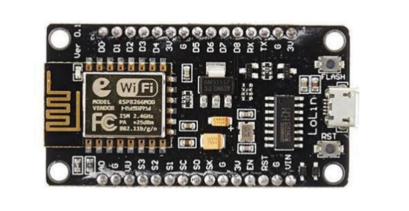

Figure 2.4.1 :ESP8266 Microcontroller

Its integrated TCP/IP stack and dual-band compatibility make it popular for usage in DIY projects, smart homes, and industrial automation.
By facilitating remote machinery monitoring and control in industrial environments, the ESP8266 improves predictive maintenance and process optimization. It makes it easier to remotely operate security systems, thermostats, and lighting in smart homes.
In this prototype, it is used to control the sensor data and transmit it into a webserver.

- ON/OFF switch:

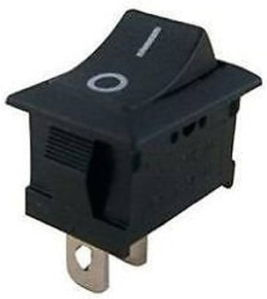
Figure 2.4.2: Dpdt switch

An ON/OFF switch is a simple electrical component that controls the flow of current in a circuit, allowing users to manually turn devices or systems on and off. It normally has two states: a closed position (ON), which completes the circuit and allows current to flow, and an open position (OFF), which breaks the circuit and stops the current. These switches are used in a number of applications, including domestic appliances, electronic gadgets, and industrial machinery. Their ease of use and dependability make them indispensable for controlling and managing power in a wide range of electrical systems.

- Led lights:

LED lights, or Light Emitting Diodes, are high-efficiency lighting solutions that have transformed the lighting business. They generate light using a semiconductor technology, which converts power into visible light with little heat generation. LED lights provide several advantages over typical incandescent or fluorescent bulbs, including a longer lifespan, lower energy usage, and a smaller environmental effect.

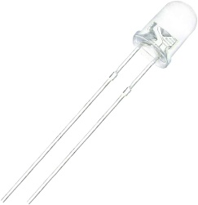
Figure 2.4.3: led bulbs

They are available in a variety of colours, brightness levels, and form factors, making them appropriate for a wide range of applications, including residential and commercial lighting, automotive, and decorative lighting. LED lights have grown in popularity due to its versatility, durability, and low cost of producing high-quality illumination.

- 12 v rechargeable batteries:

A 12V rechargeable battery is a versatile power source that is widely utilized in a variety of applications, including automotive and marine, off-grid solar systems, and portable devices. These batteries store electrical energy and may be recharged with a compatible charger, which often includes a voltage regulator to prevent overcharging.


Figure 2.4.4: 3.7V li-ion battery

They come in a variety of chemistries, including lead-acid, lithium-ion, and nickel-metal hydride, each with unique advantages in terms of energy density, lifespan, and rechargeability. These rechargeable batteries, with a nominal voltage of 12 volts, provide a dependable and portable power solution for a wide range of devices and systems, assuring continuous operation and flexibility in power management.

- AD8232 Ecg sensor :

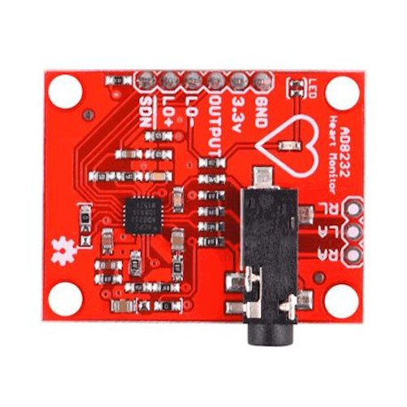
The AD8232 ECG Sensor is a compact, low-power module designed for single-lead electrocardiogram (ECG) monitoring. It is built around the AD8232 IC, which amplifies and filters weak bioelectrical heart signals to produce a clear ECG waveform. The sensor uses three electrode pads (RA, LA, RL) to capture heart activity and outputs an analog signal that can be processed by microcontrollers like Arduino, NodeMCU (ESP8266), or Raspberry Pi.
Figure 2.4.5: AD8232 ECG SENSOR

Due to its low power consumption, the AD8232 is widely used in wearable health monitoring devices, fitness trackers, and remote patient monitoring systems. It is an ideal choice for biomedical applications requiring real-time ECG visualization and analysis.

- DS18B20 Temperature Sensor :

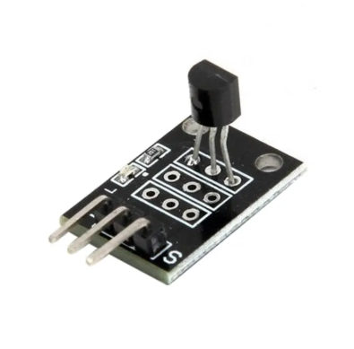
The DS18B20 Temperature Sensor is a digital thermometer that provides highly accurate temperature measurements with a resolution of 9 to 12 bits. It operates over a wide temperature range of -55°C to +125°C with an accuracy of ±0.5°C in the -10°C to +85°C range. The sensor communicates using the 1-Wire protocol, allowing multiple sensors to connect to a single microcontroller pin, making it ideal for distributed temperature monitoring. It supports both parasite power (operating with just two wires) and normal power mode.
Figure 2.4.6: ds18b20 SENSOR

The DS18B20 is widely used in industrial, environmental, and home automation applications due to its compact size, durability, and waterproof versions available for outdoor or liquid temperature sensing. It is compatible with Arduino, NodeMCU (ESP8266), Raspberry Pi, and other microcontrollers, making it a versatile choice for IoT-based temperature monitoring projects.

- MPU 6050 :

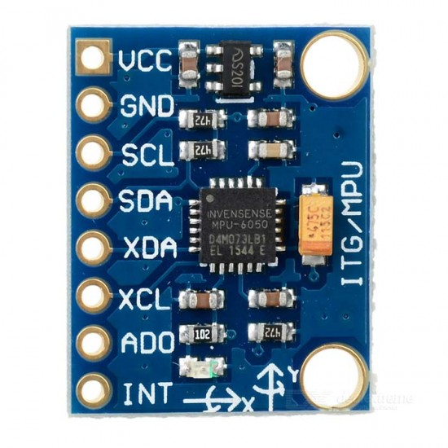
The MPU6050 is a tiny 6-axis IMU (Inertial Measurement Unit) sensor that combines a 3-axis gyroscope and a 3-axis accelerometer into a single module. It connects with microcontrollers using the I2C protocol, making it simple to connect with devices like as Arduino, NodeMCU (ESP8266), and Raspberry Pi. The sensor accurately tracks motion, detects direction, and recognizes gestures. It has an inbuilt Digital Motion Processor (DMP), which effectively processes motion data, eliminating the need for external processing.
Figure 2.4.7: MPU- 6050 SENSOR

The accelerometer and gyroscope have measurement ranges of ±2g to ±16g and ±250°/s to ±2000°/s, respectively. They are often used in robotics, drones, gaming controllers, and wearable motion tracking applications. Its small size and low power consumption make it an ideal candidate for real-time motion analysis and stabilization systems.

- MAX30102 sensor :

The MAX30102 is a high-sensitivity pulse oximeter and heart rate sensor that detects blood oxygen saturation (SpO₂) and heart rate by optical-based photoplethysmography. It uses red and infrared LEDs, a photodetector, and a low-noise analog signal processor to detect blood volume changes via fingertip or earlobe implantation. The sensor communicates using the I2C protocol, making it simple to connect with microcontrollers such as Arduino, NodeMCU (ESP8266), and Raspberry Pi.

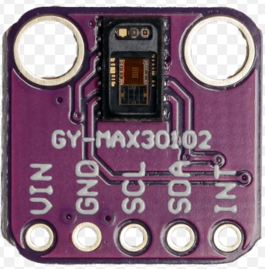
Figure 2.4.8: MPU- 6050 SENSOR

It has minimal power consumption, making it perfect for wearable health monitoring devices. The MAX30102 is extensively used in fitness trackers, medical diagnostics, and IoT-based health monitoring applications because to its small size, excellent accuracy, and real-time physiological data tracking capabilities.

CHAPTER: 03

  - PROJECT DESCRIPTION:

The Patient Health Monitoring System is an IoT-powered system that continually tracks and monitors a patient's vital health data in real time. The system is designed around a NodeMCU ESP8266 microcontroller, which gathers data from several biomedical sensors and wirelessly sends it to a cloud platform or a web server. Doctors or caregivers may now monitor patients remotely, minimizing the need for frequent hospital visits and enabling for rapid medical measures in the event of an emergency.

The system combines many sensors to assess vital health indicators. The MPU-6050 accelerometer and gyroscope monitor and identify patient movement, including falls and aberrant movements. The MAX30102 sensor detects heart rate and blood oxygen levels (SpO2) to provide continuous cardiac monitoring. The AD8232 ECG sensor monitors cardiac activity and enables healthcare providers to examine a patient's EKG in real time. Furthermore, the DS18B20 temperature sensor continually monitors body temperature, which is critical for diagnosing fevers and other medical disorders.
The system includes a web server to allow for real-time data transfer and changes. This web server guarantees that acquired sensor data is transferred and updated in real time, allowing medical practitioners to view it instantly. The NodeMCU ESP8266 analyzes the data from the sensors and sends it over Wi-Fi to the web server.
This study has several applications, including remote patient monitoring in hospitals and homes, wearable health tracking for the elderly or chronic patients, and emergency health alarm systems. In the future, the system might be improved by including AI-based anomaly detection to forecast possible health hazards, adding a GPS module to follow patients with mobility challenges, and upgrading web server functionality to give more interactive and predictive health analysis.
This Patient Health Monitoring System, which uses IoT, web technologies, and biological sensors, offers a smart, cost-effective, and efficient solution to increase healthcare accessible and maintain ongoing patient well-being.
The connection diagram of the project is shown below:

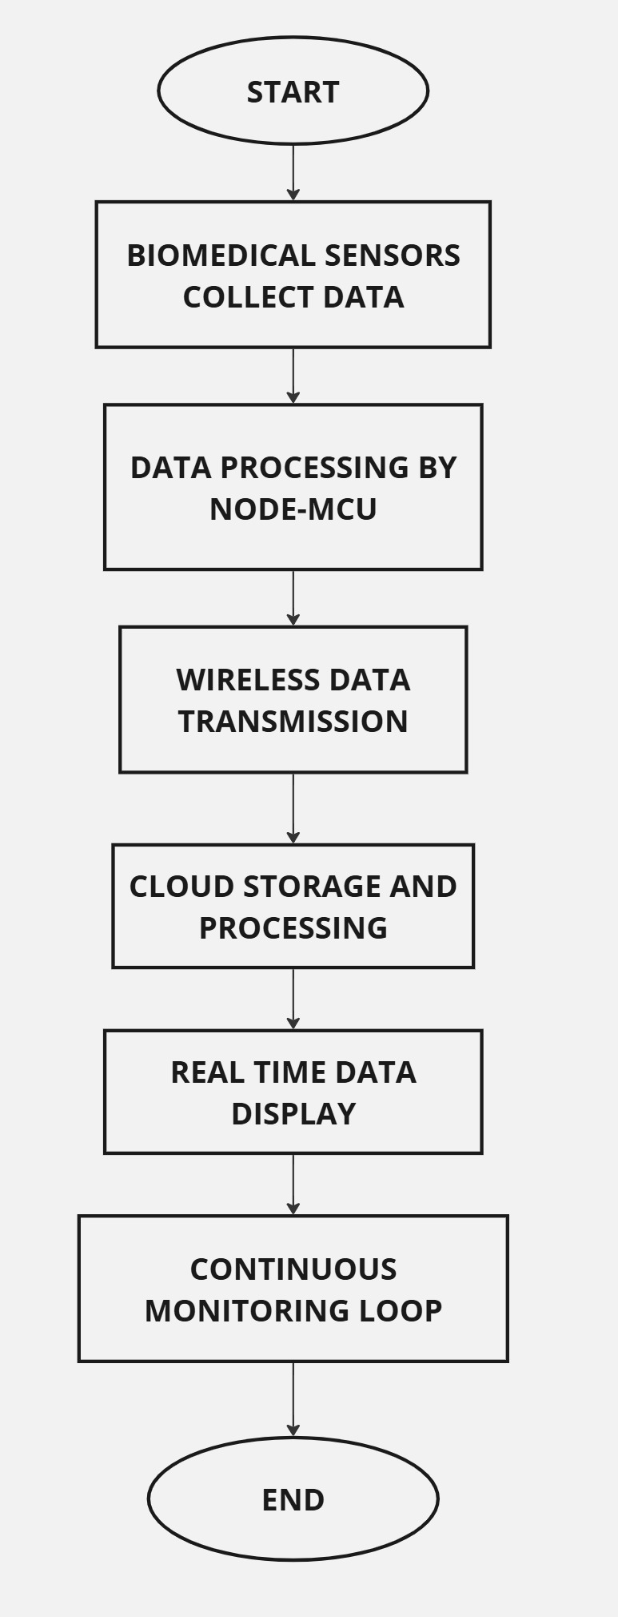
Figure 3.1.5: flowchart
The flowchart depicts the operation of VITAL-SENSE, an IoT-based patient health monitoring system, and illustrates the sequential process of real-time health tracking. Biomedical sensors monitor key health factors such heart rate, blood pressure, temperature, and SpO₂. The NodeMCU microcontroller processes the collected data, filtering and preparing it for transmission. The data is wirelessly transmitted to a cloud server, where it is stored, processed, and compared to established health criteria. The processed data is displayed in real time on a web or mobile dashboard, allowing healthcare professionals and caregivers to constantly monitor patient vital signs. If any aberrant readings are found, automatic alarms can be sent for prompt action.

3.2 PERFORMANCE ANALYSIS:

The Patient Health Monitoring System is intended to enable real-time, continuous, and precise tracking of important health metrics via a mix of IoT and web technologies. The system's performance is assessed using a number of criteria, including reaction time, data accuracy, network efficiency, power consumption, and scalability.

- Real-time data transmission: The IoT gateway provides continuous and fast updates on patient vitals. Low-latency cloud computing improves real-time monitoring, while WebSockets and MQTT can further boost data transfer efficiency.

- Biomedical sensors give accurate measurements, however extrinsic influences like mobility (heart rate, SpO₂) and temperature might impact data consistency. Advanced filtering methods can increase accuracy.

- Automated Alert System: The notification mechanism identifies aberrant vital signs and immediately warns caretakers. However, false positives may occur, necessitating adaptive threshold setting for increased dependability.

- Cloud-Based Data Management: The solution provides safe and scalable patient data storage. Encryption and HIPAA-compliant security methods assist to secure sensitive health information. Data redundancy increases dependability and prevents loss.

  - RESULT ANALYSIS:

CHAPTER : 04

4.1 APPLICATIONS AND FUTURE SCOPE:

APPLICATIONS:
- Hospitals and clinics: Enables continuous remote monitoring of ICU and post-surgery patients, decreasing the need for periodic physical examinations.

- Elderly Care Facilities: Offers round-the-clock health monitoring for older persons, recognizing early indicators of deterioration.

- Home-Based Patient Monitoring: Excellent for chronic illness management (e.g., hypertension, diabetes, cardiovascular disease), allowing patients to remain at home while clinicians monitor their vital signs remotely.

- Post-Hospitalization Care: Assists in recovery monitoring for released patients, providing quick medical intervention in the event of difficulties.

- Wearable Health Devices: Can be integrated into smartwatches or fitness bands to monitor vital signs and notify users or caregivers in real time.

- Telemedicine and Remote Healthcare: Improves virtual consultations by allowing doctors to access real-time patient data for precise diagnosis and treatment planning.

- Military and high-risk occupations: Helps troops, firemen, and industrial workers monitor stress levels, oxygen saturation, and body temperature in dangerous conditions.

- Sports and Fitness Monitoring: Helps athletes and trainers measure heart rate, SpO₂, and physical performance to avoid overexertion or injury.
FUTURE SCOPE:
- AI-Powered Health Insights:
The use of machine learning to assess patient data and forecast potential health hazards.Personalized health advice based on previous data and trends.

- Wearable and Compact Design
Creation of a wearable version for continuous, hassle-free health monitoring.Devices are lightweight and battery-efficient, making them more portable.

4.2 CONCLUSION:
VITAL-SENSE is a unique, real-time, and scalable IoT-based patient health monitoring system that aims to enhance healthcare accessibility and efficiency. Biomedical sensors, cloud computing, and automatic alerts enable continuous monitoring of important health factors including heart rate, blood pressure, body temperature, and oxygen saturation (SpO₂). This approach is especially useful for patients with chronic conditions, the elderly, post-hospitalization care, and distant healthcare services, minimizing the need for repeated hospital visits while allowing for quick medical treatments.
Real-time data transmission and cloud-based storage enable healthcare professionals and caregivers to easily monitor patient vitals from any location. Furthermore, the automated alarm system alerts medical staff or family members as soon as any irregularities occur, providing a quick reaction to severe health situations. The system's combination of IoT and wireless connection makes it cost-effective, scalable, and adaptable to a variety of healthcare situations, such as hospitals, nursing homes, and home-based patient monitoring.
Looking ahead, VITAL-SENSE has tremendous potential for further development. The use of AI-powered analytics can improve predictive healthcare by detecting early indicators of medical disorders. Furthermore, the development of wearable and small gadgets will make continuous health tracking easier and more energy-efficient. 5G and edge computing can enhance data transmission speed and latency, resulting in better real-time responsiveness.
VITAL-SENSE helps to make healthcare more intelligent, proactive, and data-driven by utilizing cutting-edge technologies. It not only lessens the load on healthcare institutions, but it also results in better patient outcomes, faster emergency response, and a higher quality of life. With ongoing innovation, it has the potential to transform remote healthcare, making medical services more efficient, accessible, and patient-centered.
REFERENCES:
- Alam, M., Siddiqui, S., & El Saddik, A. (2019). "Internet of Things in Healthcare: A Comprehensive Survey." IEEE Access, 7, 110-126. https://doi.org/10.1109/ACCESS.2019.2898187
- Kumar, R., Singh, P., & Tripathi, M. (2021). "Real-Time Patient Health Monitoring Using IoT and Cloud-Based Technologies." Journal of Medical Systems, 45(3), 56-72. https://doi.org/10.1007/s10916-021-01712-4
- Gupta, A., Sharma, P., & Verma, R. (2020). "A Smart Wearable IoT-Based Health Monitoring System for Remote Patient Care." Biomedical Signal Processing and Control, 62, 102-114. https://doi.org/10.1016/j.bspc.2020.102114
- Lee, S., Park, H., & Lee, Y. (2018). "Cloud-Based IoT-Enabled Healthcare System for Remote Monitoring." Sensors, 18(1), 200. https://doi.org/10.3390/s18010200
- Brown, D., & Zhang, T. (2019). "Machine Learning Applications in IoT-Based Patient Monitoring Systems: A Review." Healthcare Informatics Research, 25(4), 257-270. https://doi.org/10.4258/hir.2019.25.4.257
- Chen, X., Li, Y., & Wang, H. (2022). "Security and Privacy Issues in IoT-Based Healthcare Systems: A Review." Future Generation Computer Systems, 125, 94-109. https://doi.org/10.1016/j.future.2021.12.007
- Patil, P., Joshi, A., & Deshmukh, S. (2020). "Design and Implementation of IoT-Based Patient Health Monitoring System Using NodeMCU." International Journal of Engineering Research & Technology (IJERT), 9(7), 245-250.
- Shukla, R., & Singh, K. (2021). "The Role of AI in IoT-Enabled Healthcare Systems: Challenges and Opportunities." IEEE Transactions on Computational Social Systems, 8(2), 115-130. https://doi.org/10.1109/TCSS.2021.3056789
- Zhao, J., & Wu, L. (2019). "Energy-Efficient IoT-Based Patient Monitoring for Long-Term Care Facilities." Journal of Ambient Intelligence and Smart Environments, 11(3), 189-202. https://doi.org/10.3233/AIS-190521
- Yadav, M., Reddy, G., & Kumar, S. (2023). "A Review on IoT-Based Remote Health Monitoring and Challenges." Health Informatics Journal, 29(1), 1-17. https://doi.org/10.1177/14604582231103462

APPENDIX 1

ESP8266:
